**TASK 3- INSTALLING JENKINS IN LOCALHOST**

Jenkins is an open-source automation server widely used for continuous integration and continuous delivery (CI/CD). This runbook will guide you through installing Jenkins on a Windows 11 laptop, configuring it, and troubleshooting common installation issues.

**Prerequisites**

Before installing Jenkins on Windows 11, ensure the following:

* Operating System: Windows 11
* Java: Java Development Kit (JDK) 8 or later installed on your machine.
* Administrator privileges: Ensure you have administrator rights on your machine to install software.

**Install Java Development Kit (JDK)**

* Jenkins requires Java to run. If you do not have Java installed, follow these steps to install it.

**3.1. Download Java JDK**

1. Go to the official Oracle website and download the latest version of the JDK:
   * [Download Java](https://www.oracle.com/java/technologies/javase-jdk11-downloads.html)

**3.2. Install JDK**

1. Run the downloaded installer and follow the on-screen instructions to install the JDK.
2. After installation, verify Java by opening Command Prompt and running:
3. bash
4. Copy code
5. java -version
6. This will display the version of Java installed.

**3.3. Set JAVA_HOME Environment Variable**

1. Open System Properties by right-clicking This PC and selecting Properties.
2. Click on Advanced system settings > Environment Variables.
3. Under System variables, click New and add the following:
   * Variable name: JAVA_HOME
   * Variable value: Path to your JDK installation (e.g., C:\Program Files\Java\jdk-11).
4. Update the Path variable:
   * In System Variables, find Path, click Edit, and add ;C:\Program Files\Java\jdk-11\bin to the value.

**4. Download and Install Jenkins**

**4.1. Download Jenkins**

1. Visit the official Jenkins download page: Jenkins Download.
2. Choose the Windows option, which downloads the Jenkins .msi installer.

**4.2. Install Jenkins**

1. Double-click the downloaded .msi installer file to begin the installation process.
2. Follow the prompts in the installation wizard:
3. Accept the license agreement.
4. Choose the default installation directory (or select a custom directory).
5. Install Jenkins as a service (recommended).
6. Select Run Jenkins as a service at the end of installation.
7. Complete the installation by clicking Finish.

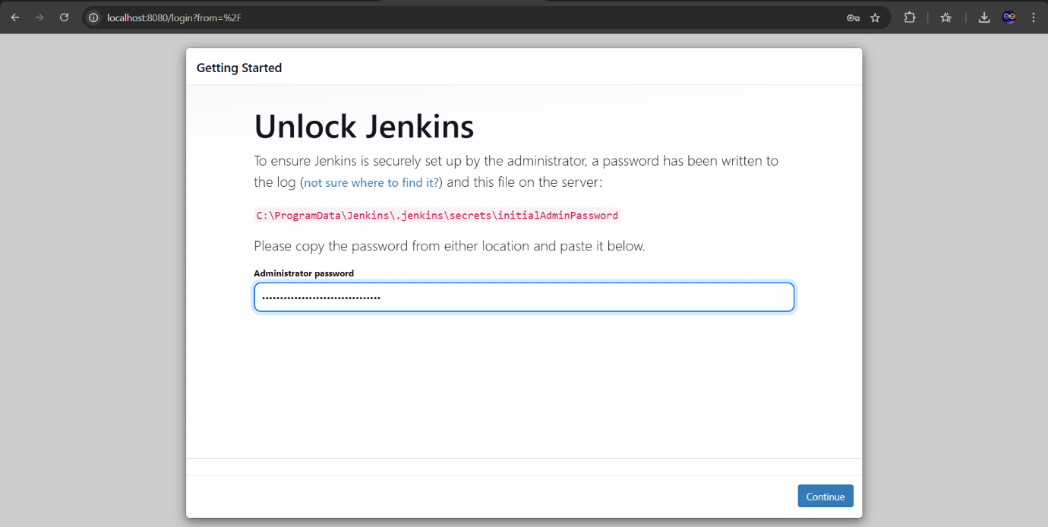

**5. Access Jenkins Web Interface**

1. Once Jenkins is installed, you can access its web interface through a browser.

**5.1. Start Jenkins Service**

1. Jenkins should start automatically as a service after installation. If not, manually start it:
2. Open the Start menu and type Services to open the Services app.
3. Find Jenkins in the list, right-click, and select Start.

**5.2. Access Jenkins**

1. Open your web browser and navigate to:
2. text
3. Copy code
4. http://localhost:8080
5. The Jenkins Setup Wizard will appear, prompting you to unlock Jenkins.

**6. Unlock Jenkins**

**6.1. Retrieve the Unlock Key**

1. After Jenkins installation, an unlock key is generated and stored in the following file:
2. Default location: C:\Program Files (x86)\Jenkins\secrets\initialAdminPassword
3. Open the initial admin password file with a text editor (such as Notepad) to retrieve the password.

**6.2. Enter the Unlock Key**

1. Copy the unlock key and paste it into the Jenkins Setup Wizard.
2. Click Continue.

**7. Install Suggested Plugins**

1. After unlocking Jenkins, the Setup Wizard will prompt you to install plugins.
2. Select Install Suggested Plugins to install a recommended set of plugins for Jenkins.
3. Note: This may take a few minutes depending on your internet connection.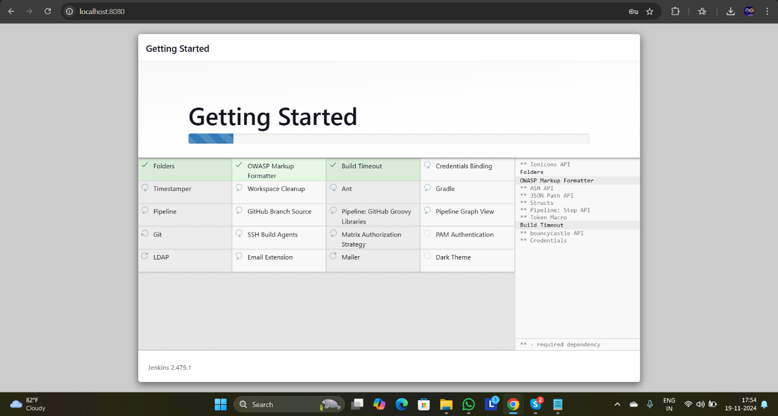

**8. Create Admin User**

1. Once the plugins are installed, Jenkins will prompt you to create an admin user.
2. Enter the following details:
   * Username: Enter a username for the Jenkins admin account.
   * Password: Enter a secure password.
   * Full Name: Enter your full name.
   * Email Address: Enter a valid email address.
3. Click Save and Finish.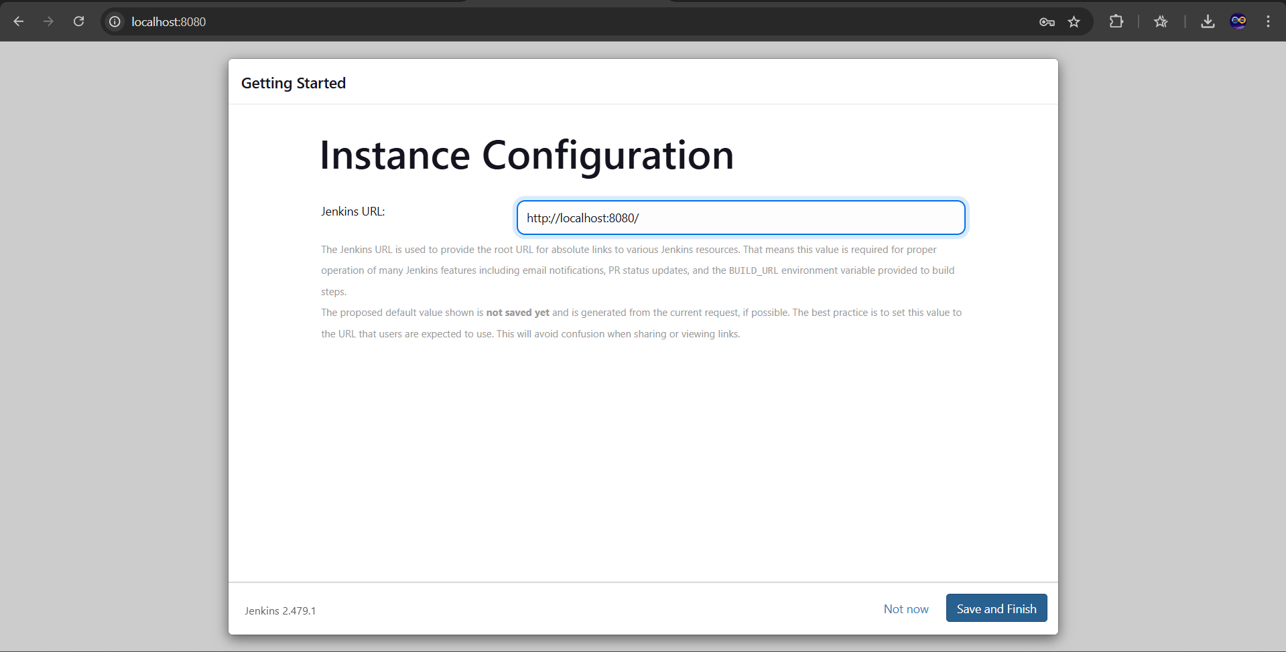

**9. Jenkins Is Ready to Use**

After completing the setup, Jenkins will be ready to use. You can now access Jenkins through the web interface at <http://localhost:8080>.

**WELCOME TO JENKINS**

